**DAILY ONLINE ACTIVITIES SUMMARY**

|  |  |  |  |  |  |  |  |  |
| --- | --- | --- | --- | --- | --- | --- | --- | --- |
| **Date:** | **04/06/2020** | | | | | **Name:** | **POOJA D S** | |
| **Sem & Sec** | **4th SEM 'B' Section** | | | | | **USN:** | **4AL18CS056** | |
| **Online Test Summary** | | | | | | | | |
| **Subject** | | **Microcontroller and Embedded System** | | | | | | |
| **Max. Marks** | | **20** | | **Score** | | | **15** | |
| **Certification Course Summary** | | | | | | | | |
| **Course** | **Computer Vision Essentials** | | | | | | | |
| **Certificate Provider** | | | **Great Learning Academy** | | **Duration** | | | **5.5 hour** |
| **Coding Challenges** | | | | | | | | |
| **Problem Statement:** A user will input two strings, and we find if one of the strings is a sub sequence of the other. Program prints “yes” if either the first string is a sub sequence of the second string or the second string is a sub sequence of the first string. Assume that, the length of the first string is smaller than or equal to the length of the second string. Assume that, the length of the first string is smaller than or equal to the length of the second string. | | | | | | | | |
| **Status: completed** | | | | | | | | |
| **Uploaded the report in Github** | | | | | **yes** | | | |
| **If yes Repository name** | | | | | <https://github.com/dspooja/C-coding>  <https://github.com/dspooja/Java-coding> | | | |
| **Uploaded the report in slack** | | | | | **yes** | | | |

Online Test Details: (Attach the snapshot and briefly write the report for the same)

Certification Course Details: (Attach the snapshot and briefly write the report for the same)

Coding Challenges Details: (Attach the snapshot and briefly write the report for the same)

ONLINE TEST DETAILS:

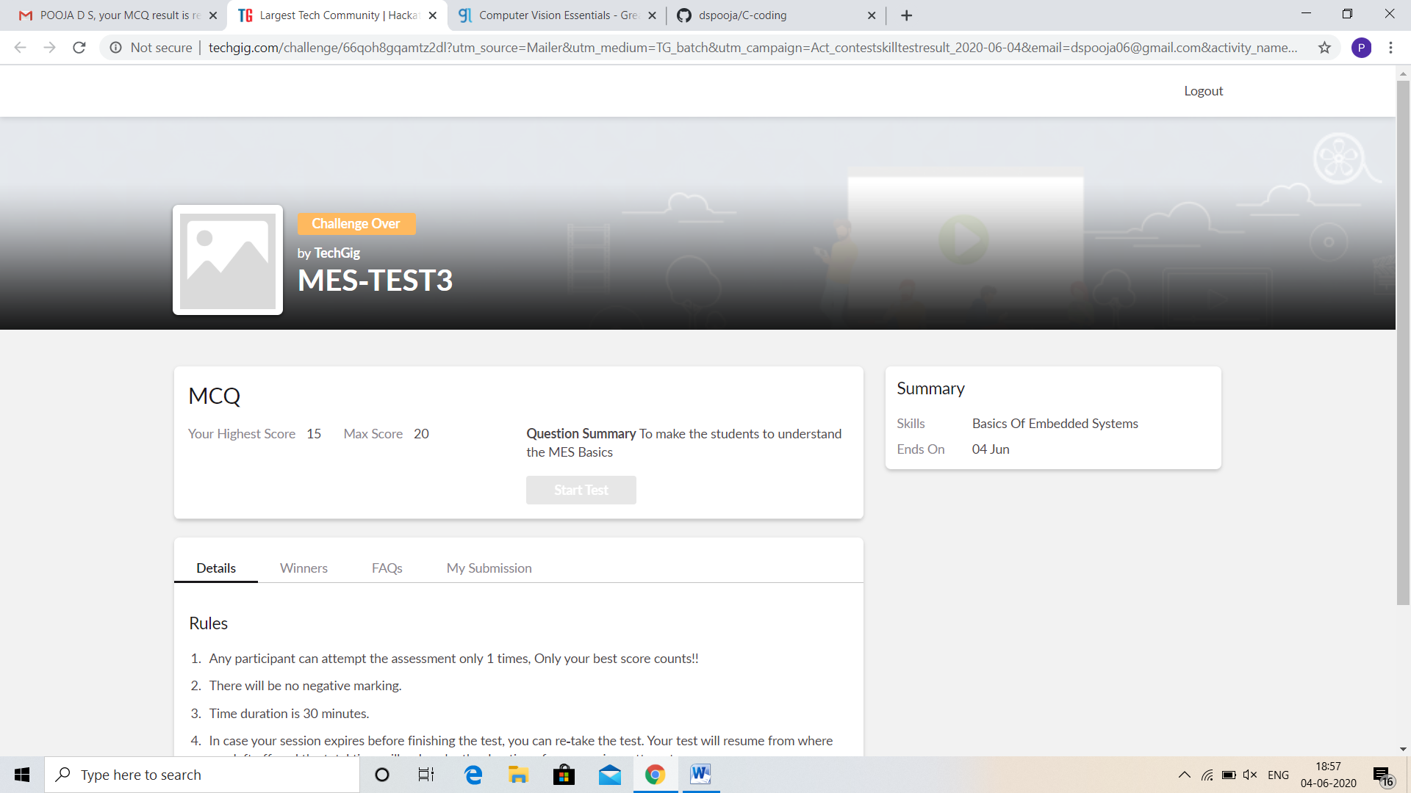

CERTIFICATION COURSE DETAILS:

* As continuation of the **Computer Vision Essentials** online course**.**
* **The concepts covered in Computer Vision Essentials are:**
* CNN Architectures and LeNet Case Study
* Case Study : AlexNet
* Case Study : ZFNet and VGGNet
* Case Study : GoogleNet

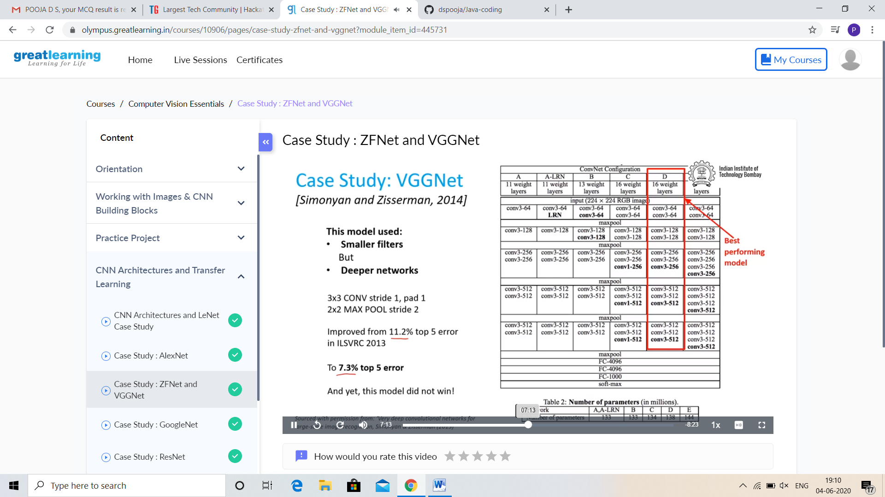

I Participated in the Webinar entitled “Opportunities in IT Hardware Sector”.

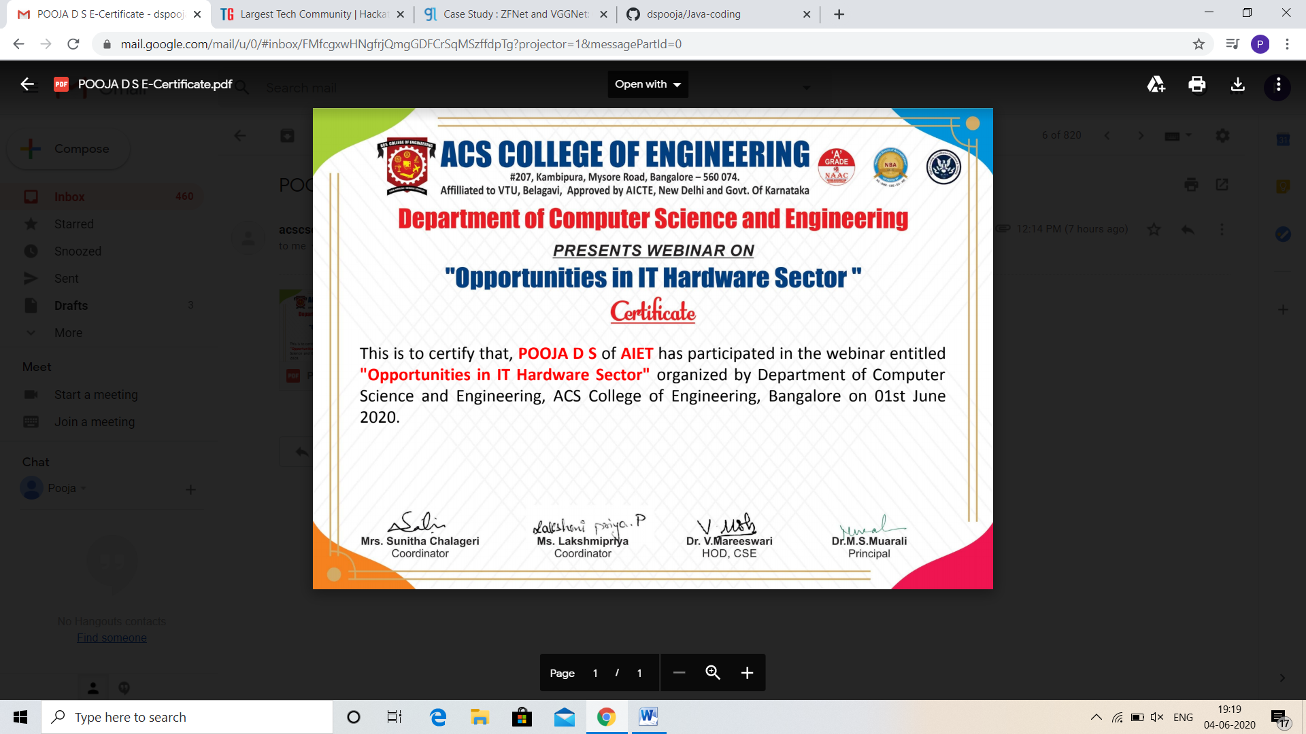

CODING CHALLENGES DETAILS:

Problem statement 1:

Write a C++ program to find the missing number in array.

Given an array C of size N-1 and given that there are numbers from 1 to N with one element missing, the missing number is to be found.

**Input:**  
The first line of input contains an integer T denoting the number of test cases. For each test case first line contains N(size of array). The subsequent line contains N-1 array elements.

**Output:**   
Print the missing number in array.

**Constraints:**   
1 ≤ T ≤ 200  
1 ≤ N ≤ 107  
1 ≤ C[i] ≤ 107

Example:   
Input:   
1  
5  
1 2 3 5

Output:   
4

Solution: Uploaded it in github

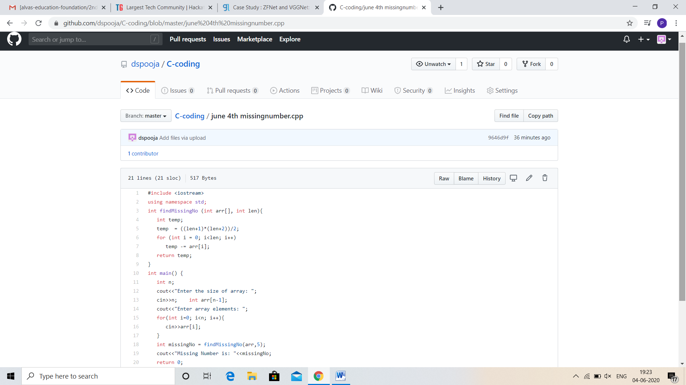

Problem statement 2:

Java program

Write a java program to read three integer values from the keyboard and find the sum of the values. Declare a variable "sum" of type int and store the result in it.

Solution: Uploaded in github.

